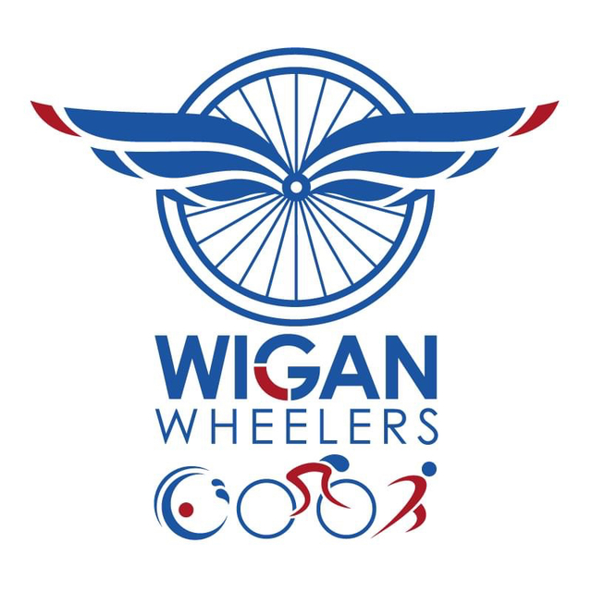
Wigan Wheelers - Open 25 Miles TT L2525/1
Sunday 9th May 2020 START SHEET
Promoted for and on behalf of Cycling Time Trials under their rules and regulations
**Please note due to the ongoing COVID-19 pandemic CTT have completed an additional risk assessment on how events can be conducted. Note this event will work differently from previously and is vitally important you read the COVID-19 guidance in the document below. If further updates come into effect prior to the event starting I will inform you via email asap, or on the day of the event.
Event Secretary: Amanda Asbridge. 4 Stockwell Close, Winstanley, Wigan. WN3 6EH. 077200 60021
Time Keeper: Derek Black (finish) and Amanda Asbridge (start)
Signing in and out and numbers: North end of Cockerham Road – competitors cars are not be parked here, use only to sign in and out and collect and return number. Please find a different road to park any vehicles.
Signing on opens from 6.30am First rider off 07.08am Teams will go off at 2 minute intervals
Please allow 5 minutes to ride to the start.
Course L2525/1
START in the south end of the southernmost of two entrances to access road to houses facing A6 opposite junction with Parkside lane and adjacent to Elite Motors Garstang. Proceed south on the A6 though Claughton, Brock, (Care at Roundabout, 3.2m), Billsborrow and Barton to **Broughton roundabout (6.75m) where take first exit onto James Towers way. **Proceed to the roundabout junction with the B5269 Whittingham lane (7.2m). Encircle roundabout and retrace to Broughton roundabout where turn right to rejoin A6 north (CAUTION at traffic island at Barton Grange) to Kirkland Bridge. to turn left on to the A586 (13.25 miles). Proceed through St. Michaels to the bottom of Great Eccleston by-pass where bear left (17.6 miles) and continue through village to T-junction with A586 at top of by-pass (18.2 miles). Turn right (Care) on to the A586 and retrace through St. Michaels to junction with A6 at Kirkland Bridge (23.2 miles). Turn left and proceed north on A6 to FINISH on the second of two brows at lamp post number 393, approx 400 yards south of traffic lights on Garstang by-pass (25 miles).
**Riders must be aware of the 2 Toucan Crossings on this course. One before the New Broughton Roundabout and One before the New Whittingham Lane Roundabout. Riders must STOP if required.

PRIZE LIST: (One team prize per team, except club prize) (Monies are per team and not individual)

Fastest Team Overall - £60 Fastest Mixed Team - £40 (vet, sen, espoir, lady)
2nd Team Overall - £40 Fastest Veteran Team - £40
3rd Team Overall - £30 Fastest age under 40 team - £40
Fastest Tandem - £40

Fastest Club Prize – 2 x 2 teams (4 riders from the same club as a pair) - £40

The following Local Regulations have been approved by the National Committee in accordance with Regulation 38 any breaches may lead to disciplinary action being taken.
CTT Regulation 17: Signing-on & signing-out sheet
a) The competitors in all types of events must make themselves aware of any special instructions for the event and sign the official signing on sheet when collecting their number.
b) In type A events a competitor must return to the HQ either during the event or within a reasonable time after the last rider has finished the event and must (i) return their number and (ii) sign the official signing out sheet.
There will be a copy of the new risk assessment for viewing at the headquarters.
Local Reg. No. 4a – For all events on Sunday mornings, motor vehicles must NOT be parked in Cockerham Road.
Local Reg No. 5 - In all events, competitors prior to starting are NOT permitted to ride past the finishing timekeeper during the duration of the event.
Local Reg No.6 - Any competitors making a U turn in the vicinity of the start or finish will be disqualified from the event.
Local Reg No.15 - Riders must keep to the left hand side of the road except when overtaking. Failure to comply with the above may lead to disqualification.
IN ADDITION TO THE ABOVE
Riders must give their number at the finish and elsewhere on the course if requested.
Riders must NOT STOP ON the A6 after passing the timekeeper as this is a clearway. (The clearway is from the south end of Garstang by-pass to Hampson Green roundabout).
Riders MUST NOT STAND in the road at the start or finish. (This constitutes obstruction and is a breach of regulations.)
Riders must NOT ride with their heads down.
Riders must be aware of the 2 Toucan Crossings on this course. One before the New Broughton Rouandabout and one before the New Whittingham Lane Roundabut. Riders must SOP if required.
Rider Safety Helmets:
All competitors under the age of 18 and/or juniors must wear a HELMET of HARD/SOFT SHELL construction that conforms to a recognised Standard (See Regulation 15). Cycling Time Trials strongly recommends ALL competitors to wear such a helmet.
Competitor Machines - Lights:
CTT recommends that a working rear light, either flashing or constant, is fitted to the machine in a position clearly visible to following road users and is active whilst the machine is in use.
This event may be subject to a Doping Control
It is your responsibility to check as soon as you have finished you should return to the event HQ as it is your responsibility to check if you are required for Doping Control Race numbers required for Doping Control will be displayed at the HQ adjacent to the result board If your number is displayed you should report immediately to Doping Control which will be nearby. Remember, it is up to you to check and ensure that you comply If required you must report to Doping Control after finishing without delay.

COVID 19 Guidelines
* Failure to abide by the COVID-19 risk assessment could result in suspension of CTT activities and issues with local authorities and specific courses.
* For the ongoing prosperity of the sport you follow the guidelines to the letter.
* There are no toilet facilities available.
* Signing-On and Signing-Out sheet New measures in place – there will be a one-way system to sign on before & out after your ride. Please observe social distancing & PLEASE BRING YOUR OWN PINS, PEN AND MASK
* No result board will be displayed at the event, complete times will only be available via the CTT website post event.
* Provisional results posted on Wigan Wheelers and Triathlon Club facebook page after the event.
* All prizes will be posted out or contacted for bank details. (one rider one prize).
* If you are not well or showing signs of COVID-19 please do not attend.
* Please socially distance at all times.
* If you are more comfortable in a mask please wear one.
* Competitors must only be at the start no more than 4 minutes before your start time.
* No jackets or bottles etc to be left with timekeepers or marshals.
* Sign on with your own pen
* Bring your own pins. Pin on your own number.
* Please do not assist fellow competitors.
* Bring a first aid kit
* Do not throw away any gel wrappers on the course, please collect and take home to dispose.

